Project Design Phase
Solution Architecture

Date | 15 February 2025
Team ID
Project Name | AI FAQ Assistant
Maximum Marks | 4 Marks

Solution Architecture:
Solution architecture is a complex process – with many sub-processes – that bridges the gap between business problems and technology solutions. Its goals are to:
- Find the best tech solution to solve existing business problems.
- Describe the structure, characteristics, behavior, and other aspects of the software to project stakeholders.
- The AI FAQ Assistant follows a layered architecture where the user submits a question through the interface.
- The question is pre-processed and analyzed using Natural Language Processing (NLP) techniques.
- The AI engine identifies the user's intent and searches the FAQ database or knowledge base for relevant information.
- The most appropriate answer is then generated and displayed to the user through the interface.
- This architecture enables quick, accurate, and automated responses to frequently asked questions.

Example - Solution Architecture Diagram:

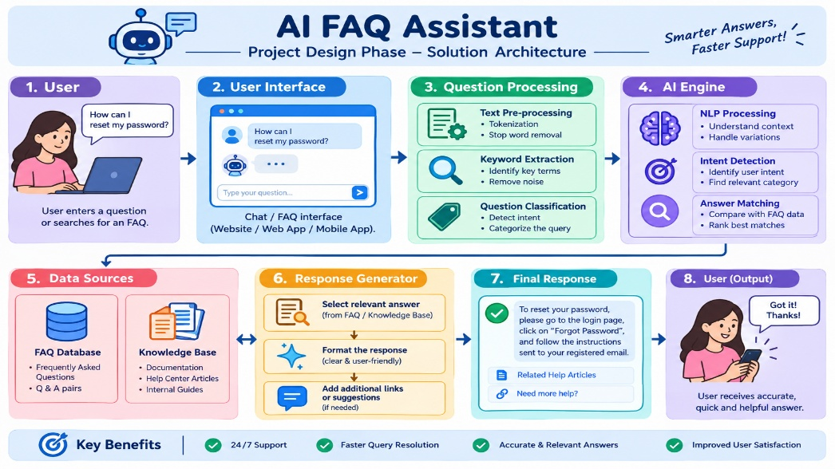
Figure 1: Architecture and data flow of the voice patient diary sample application
Reference: https://aws.amazon.com/blogs/industries/voice-applications-in-clinical-research-powered-by-ai-on-aws-part-1-architecture-and-design-considerations/

